Alabama Department of
Child Abuse & Neglect Prevention’s

Prevention Month Toolkit

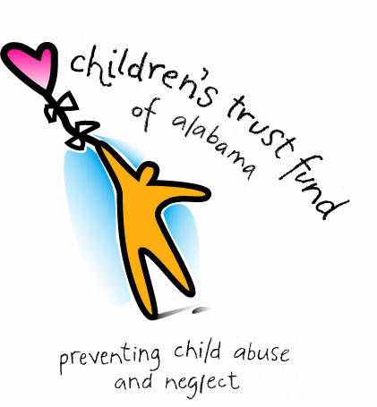
35th
35 years of preventing child abuse and neglect

www.ctf.alabama.gov
334-262-2951
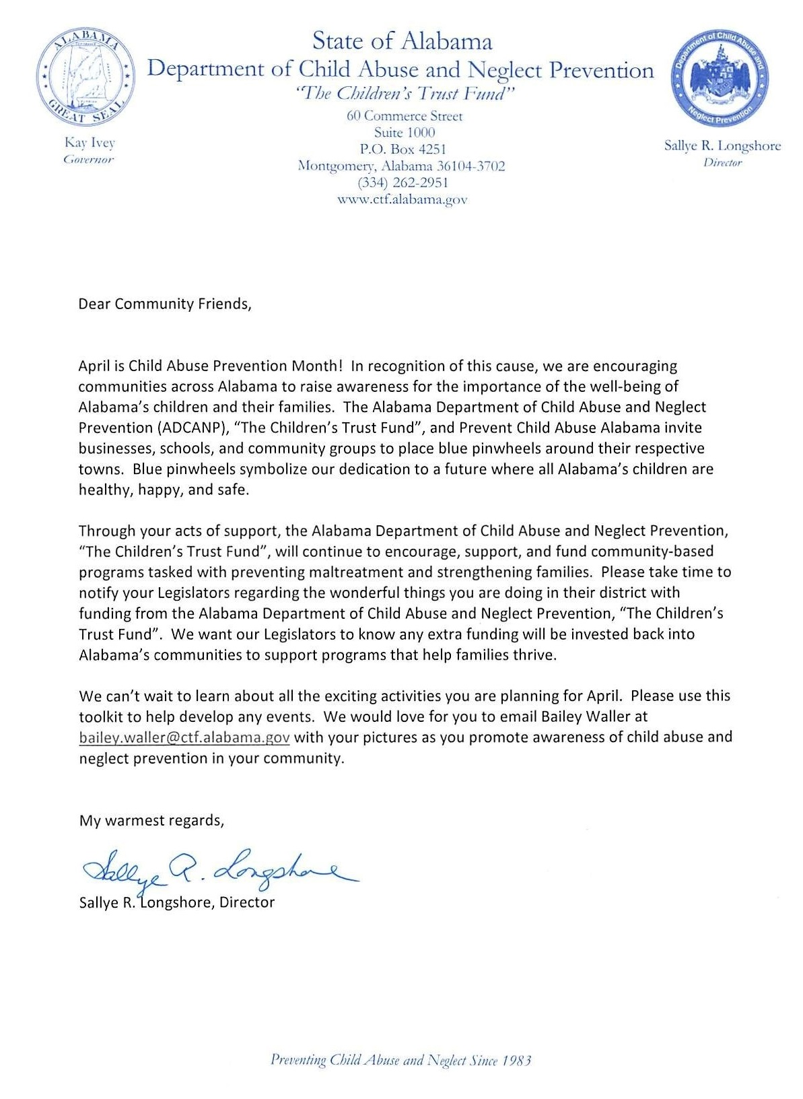
Table of Contents

Overview of Department...………………………………………………….…..4
Overview of Prevention Month…………………………………….………...5
Activities………………………………………………………………………………….6
Media Tips…..………………………………………………………………………....8
Social Media…………………………………………………………………………10
Proclamation…………………………………………………………………..…….13
Public Service Announcements………………………………………….....15

Overview of Department

About Us
- The Alabama Department of Child Abuse & Neglect Prevention, The Children’s Trust Fund, is the only statewide organization designated to prevent child abuse and neglect. We advocate for children and the strengthening of families.
- In 1983, the Alabama Legislature adopted Alabama’s Child Abuse & Prevention Act creating the Children’s Trust Fund to address the state’s growing problem of child neglect and maltreatment. While several state agencies worked on different aspects of child abuse, none of these specifically focused on solving the problem before it occurred.
- In 2007, the Department was established as the Alabama chapter for Prevent Child Abuse America since our state agency and the national organization share the same mission of preventing child abuse and neglect before it occurs.

Our Work
- The agency funds, supports, and monitors evidence-based community programs statewide that are committed to prevention of child maltreatment. The types of programs funded by the ADCANP include: parent education and support, fatherhood, home visiting, respite care, mentoring, and public awareness.
- The programs are funded through a competitive grant application process and supported by state and federal dollars.

Significance
- In Alabama, child abuse and neglect costs taxpayers $2.3 billion dollars every year which equates to an average cost of $175,344 per child (The University of Alabama College of Human Environmental Science and Center for Business and Economic Research, 2015).
- According to the 2017 Alabama Kids Count Data Book, there were nearly 40,000 unduplicated child abuse and neglect reports and approximately 10,000 victims in fiscal year 2016.

Program Data
- For the 2017-2019 Program Year, the agency funded 153 community-based programs statewide that provide essential services to children and families committed to the prevention of child abuse and neglect.

Overview of Prevention Month

National Child Abuse Prevention Month is a time to acknowledge the importance of families and communities working together to prevent child abuse and neglect, and to promote the social and emotional well-being of children and families. During the month of April, communities are encouraged to share child abuse and neglect prevention awareness strategies and activities that promote prevention across the country.
Child Abuse Prevention Month Theme
Prevent Child Abuse America has announced that the 2018 Child Abuse Prevention Month theme is "Help Great Childhoods Happen." There are three main components:
- Help Great Childhoods Happen Digital Campaign: Throughout April, Prevent Child Abuse America has demonstrated how we can all support great childhoods and promote the 30 things you should know to help make great childhoods happen.
- Wear Blue Day: On Friday, April 6th, individuals and organizations across the US will band together to make a visible commitment to preventing child abuse and helping make great childhoods happen nationwide by wearing blue.
- Pinwheels & Pinwheel Gardens: The pinwheel has come to serve as the national symbol of the great childhoods we want for all children. Throughout April, planting pinwheel gardens in honor of children in communities nationwide demonstrates how we can all support great childhoods and promote ways to help great childhoods happen.
Why Child Abuse Prevention?
When we invest in healthy child development, we are investing in community and economic development. Unfortunately, children are sometimes exposed to extreme and sustained stress like child abuse and neglect, which can undermine a child’s development. Research conducted by Prevent Child Abuse America estimates that implementing effective policies and strategies to prevent child abuse and neglect can save taxpayers $80 billion per year. Prevention strategies are shown to reduce costs for foster care services, hospitalization, mental health treatment and law enforcement, as well as loss of individual productivity and expenditures related to chronic health problems, special education and the justice system.
National Resources:
- National Child Abuse Prevention Month: https://www.childwelfare.gov/topics/preventing/preventionmonth/
- Activity Calendars: https://www.childwelfare.gov/topics/preventing/preventionmonth/get-involved/activity-calendars/
Activities
For Child Abuse Prevention Month, we encourage you to get creative in hosting a special event or preparing materials that promote prevention. Here are some ideas of popular activities that you can implement throughout your organization, network, and community.

Wear Blue Day
Participate in the national “Wear Blue Day” on Friday, April 6th! Or you can always designate another day in April or a day of the week throughout the month as “Wear Blue Day” as blue is the color of prevention. Once you have a date(s) set, encourage everyone in the community to participate, including schools, churches, and organizations.

Pinwheel Garden
Create a garden of pinwheels, the national symbol for child abuse prevention, to help remind the community of what the pinwheel represents, which is a chance of a healthy, happy, and full life that all Alabama children deserve.

Balloon Release
Bring together a group of people to release blue balloons in recognition of the importance of child abuse prevention.

Paint the Town Blue
Get creative in ways you can showcase the color blue throughout your community. Here are a couple of ideas:
- Get permission to illuminate a prominent building or fountain in blue for the month. This can be done by covering the outside lights of the building/foundation with blue film.
- Have organizations, businesses, and families display blue ribbons or bows on their doors or mailboxes

Legislator Visits
Since the Alabama Legislature is typically in session during April, this is a great opportunity to visit the State House and set up a meeting with your State Senator and Representative to emphasize the importance of child abuse and neglect prevention. If you’re not able to meet with them, you can always call, write a letter, or email them! Their contact information can be found online here: www.legislature.state.al.us/aliswww/default.aspx

Open House
Grantees and partners of the Alabama Department of Child Abuse and Neglect Prevention are encouraged to host an Open House inviting the community to visit and learn more about them and their role in child abuse and neglect prevention.

Email Signatures
This is a simple, easy way to increase awareness! Edit your email signature for April to add a line promoting prevention month. Here’s an example:
- April is Child Abuse Prevention Month! Help support Alabama’s child abuse and neglect prevention programs here: www.ctf.alabama.gov
Children’s Activities
Involve children in child abuse prevention month! Here are a couple of fun activities for them:
- Pinwheel Coloring Sheet: http://preventchildabuse.org/wp-content/uploads/2016/02/PinwheelColoringSheet_National.pdf
- Make your own paper pinwheel: http://preventchildabuse.org/wp-content/uploads/2016/02/MakeYourPinwheel_National.pdf

Media Tips

If you host an event or activity in April, you can help secure media there by drafting a media advisory. A media advisory is sent 3-4 days before an event to invite the media. It typically includes just enough information to get the media there, such as logistics of who, what, when, where, and why. Also, your organization can send out a press release to your local newspaper and TV contacts via email notifying them about child abuse prevention month and the importance of spreading awareness throughout the community. We’ve included samples of both below.

Media Advisory
CITY, AL – [Name of Organization(s)] and the Alabama Department of Child Abuse and Neglect Prevention are raising awareness about Child Abuse Prevention Month by hosting a [describe event or activity] on [Date] [Location] [Location Address].

WHAT: [Describe event or activity];
WHEN: [Date and Time];
WHERE: [Location and Address];
WHO: [Describe who will be at the event or activity]
WHY: [Describe the event or activity’s significance to child abuse prevention month]

For more information, please contact (Name of event’s contact) at (Phone Number).

Press Release
April is Child Abuse Prevention Month: Help Great Childhoods Happen!
The Alabama Department of Child Abuse & Neglect Prevention, in partnership with (Name of your local organization), is encouraging Alabamians to get involved with child abuse prevention activities throughout the month of April

(Name of City), Alabama – April is Child Abuse Prevention Month and the Alabama Department of Child Abuse and Neglect Prevention, also known as “The Children’s Trust Fund,” and (Name of Organization) are spreading the message that everyone can help great childhoods happen in their community.

(Name Organization), a grantee organization of the Alabama Department of Child Abuse and Neglect Prevention, encourages all individuals and organization to play a role in making (COMMUNITY NAME) a better place for children and families. By ensuring that parents have the knowledge, skills, resources they need to care for their children, we can help promote children’s social and emotional well-being and prevent child maltreatment within families and communities.

(List ways the community can get involved and mention in special events or activities you have planned, i.e. Wear Blue Day on Friday, April 6th.)

“April is a time to celebrate the important role that communities play in protecting children,” said (YOUR SPOKESPERSON’S NAME AND TITLE). “Everyone’s participation is critical. Focusing on ways to build and promote the protective factors, in every interaction with children and families, is the best thing our community can do to prevent child maltreatment and promote optimal child development.”

###
About the Alabama Department of Child Abuse and Neglect Prevention
The Alabama Department of Child Abuse and Neglect, a state agency founded in 1983, secures resources to fund evidence-based community programs committed to the prevention of child maltreatment.

Social Media
Social media is a free and effective tool for increasing awareness during Child Abuse and Neglect Prevention Month. We’ve included sample Facebook and Twitter posts you can use below. Also, we encourage you to use the following hashtags when sharing pictures and messages about child abuse prevention month to help us track the conversations on both the national and state level. When possible, please tag of us in your posts! Our Facebook and Twitter Account is @CTFofAL
- National Hashtags: #CAPMonth and #GreatChildhoods

Facebook Posts
Social art | Headline | Content
 | Every child deserves to grow up feeling safe and loved | Every parent needs support to help #GreatChildhoods happen. That’s why we’re here—but we need your help, too! April is Child Abuse Prevention Month. #CAPMonth
 | Wear blue on April 6 to support #GreatChildhoods! | Get ready for #WearBlueDay this Friday! Show your support for #GreatChildhoods, and help prevent child abuse. #pinwheelsforprevention
 | Wear blue on April 6 to support #GreatChildhoods! | It’s #WearBlueDay! Wear your favorite blue jeans, blue hoodies, blue everything! Show everyone you support #GreatChildhoods. #pinwheelsforprevention
 | Great neighbors make #GreatChildhoods | Lots of parents need help, even when they don’t know how to ask for it. Be the help they need, so #GreatChildhoods can happen! #CAPMonth
 | Speak up for #GreatChildhoods | Your voice can make a difference for kids, from your hometown to the halls of Congress! Speak up for safer kids— we’ll help you get started! #GreatChildhoods #pinwheelsforprevention
 | Help #GreatChildhoods happen | Our programs help kids & families create #GreatChildhoods. Help us help them, and together we can prevent child abuse. #CAPMonth
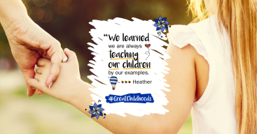 | “We are always teaching our children by our examples.” —Heather | How can you help prevent child abuse? Get involved with local groups that help young moms. We’ll show you how! #GreatChildhoods #CAPMonth
 | Help kids be more ready for school | Kids in Healthy Families America are nearly twice as likely to excel at kindergarten learning behaviors. That’s how #GreatChildhoods happen! #pinwheelsforprevention
 | Every child deserves to grow up feeling safe and loved | You can play a role in preventing child abuse, by getting involved letting your voice be heard. Learn how you can help kids in our area have the #GreatChildhoods they deserve—starting today! #CAPMonth
 | Great neighbors make #GreatChildhoods | You can help prevent child abuse by helping parents be the best moms and dads they can be. We’ll show you how to get involved! #GreatChildhoods #CAPMonth
 | Speak up for #GreatChildhoods | Tell your elected officials at every level that you support programs that promote #GreatChildhoods. We’ll help you get started! #pinwheelsforprevention
 | Help #GreatChildhoods happen | Thank you for your donations during Child Abuse Prevention Month! #pinwheelsforprevention You’ve helped create #GreatChildhoods in our community all year long.

Twitter Posts
Social art | Headline | Content
 | Every child deserves to grow up feeling safe and loved | Every parent needs support to help #GreatChildhoods happen. April is Child Abuse Prevention Month. #CAPMonth
 | Great neighbors make #GreatChildhoods | Parents need help, even when they don’t ask for it. Be the help they need, so #GreatChildhoods can happen! #CAPMonth
 | Wear blue on April 6 to support #GreatChildhoods! | Get ready for #WearBlueDay this Friday! Show your support for #GreatChildhoods, and help prevent child abuse.
 | Wear blue on April 6 to support #GreatChildhoods! | It’s #WearBlueDay! Wear your favorite blue everything! Show everyone you support #GreatChildhoods.
 | Help #GreatChildhoods happen | Our programs help kids & families create #GreatChildhoods. Together we can prevent child abuse. #CAPMonth
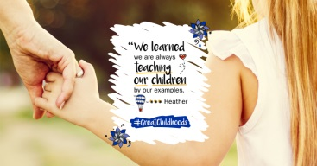 | “We are always teaching our children by our examples.” —Heather | How can you help prevent child abuse? Help young moms. We’ll show you how! #GreatChildhoods #CAPMonth
 | Help kids be more ready for school | Kids in Healthy Families America are nearly twice as likely to excel in kindergarten. That’s how #GreatChildhoods happen!
 | Great neighbors make #GreatChildhoods | You can help prevent child abuse by helping local parents. We’ll show you how! #GreatChildhoods #CAPMonth
 | Speak up for #GreatChildhoods | Your voice can make a difference for kids, from your hometown to the halls of Congress! #pinwheelsforprevention
 | Help #GreatChildhoods happen | Thank you for your donations during #CAPMonth! You’ve helped create #GreatChildhoods in our community all year long.

Proclamation

Each year in April, the President of the United States issues a proclamation to announce National Child Abuse Prevention Month. Many State Governors, including Alabama’s Governor, also issue proclamations to encourage public awareness of child abuse and neglect, recommit State resources to the cause, and promote community involvement through State activities. At the local level, we encourage Alabama’s cities and communities to request a proclamation from their mayor. Here’s a sample request letter and proclamation to use.
Request Letter
(Address)
(Date)
Dear Mayor (Name),
As you may know, April is nationally designated as Child Abuse Prevention Month to increase awareness on the importance of child abuse prevention. As your constituent, I am asking if you will join me and the Alabama Department of Child Abuse and Neglect Prevention in promoting prevention by proclaiming April as Child Abuse Prevention Month in (name of community).
The 2016 Alabama Kids Count Data reported there were nearly 33,000 reports of child abuse and/or neglect, impacting more than 8,400 children, which emphasizes this is not only an issue nationally but also locally. That’s why it is critical for our community to come together in April and share resources as well as strategize on what we can do to reduce the likelihood of child abuse and neglect.
Please consider signing a proclamation for Child Abuse Prevention Month in (name of community) to remind us all of the collective responsibility we have to protect the children of (name of community).
With much appreciation,
(signature)
(name, title, organization)
Mayor’s Proclamation
Whereas, preventing child abuse and neglect is a community problem that depends on involvement among people throughout the community; and
Whereas, child maltreatment occurs when people find themselves in stressful situations, without community resources, and don’t know how to cope; and
Whereas, the majority of child abuse cases stem from situations and conditions that are preventable in an engaged and supportive community; and
Whereas, child abuse and neglect can be reduced by making sure each family has the support they need to raise their children in a healthy environment; and
Whereas, child abuse and neglect not only directly harm children, but also increase the likelihood of criminal behavior, substance abuse, health problems such as heart disease and obesity, as well as risky behavior such as smoking; and
Whereas, all citizens should become involved in supporting families in raising their children in a safe and nurturing environment; and
Whereas, effective child abuse prevention programs succeed because of partnerships created among social service organizations, schools, faith communities, civic organizations, law enforcement agencies, and the business community;
Now Therefore, I, ________________________, Mayor of _____________________, on behalf of the Alabama Department of Child Abuse and Neglect Prevention, The Children’s Trust Fund, do hereby proclaim April 2018 as Child Abuse Prevention Month.

Public Service Announcements

PSA #1
(Name of organization) is a partner organization with the Alabama Department of Child Abuse and Neglect Prevention by working to prevent child abuse and neglect. During the month of April, (name of organization) and the Alabama Department of Child Abuse and Neglect Prevention encourages you to join them in observing Child Abuse Prevention Month. Everyone can play a role in prevention. This message is brought to you by (name of organization) and the Alabama Department of Child Abuse and Neglect Prevention.

PSA #2
There are many ways to help strengthen families and prevent the likelihood of child abuse and neglect. During April, which is designated as Child Abuse Prevention Month, what can you do to strengthen families? Reach out to a parent, volunteer with a prevention program, or put a blue ribbon on your door? Together we can raise awareness and reduce the risks of child abuse and neglect in (name of community). This message is brought to you by (name of organization) and the Alabama Department of Child Abuse and Neglect Prevention.

PSA #3
April is Child Abuse and Neglect Prevention Month! During this month and throughout the year, (name of organization) is supporting the mission of the Alabama Department of Child Abuse and Neglect Prevention of advocating for children and the strengthening of families. Throughout April, please consider helping to promote child abuse and neglect prevention in (name of community). This message is brought to you by (name of organization) and the Alabama Department of Child Abuse and Neglect Prevention.

